Home Page

TC_001

Verify that the "Latest News" section is displayed correctly

1. Open the application > 2. Scroll down to the "Latest News" section > 3.Check if news items are displayed correctly > 4.Verify that the date format is correct

Enquiry page is not display proper format

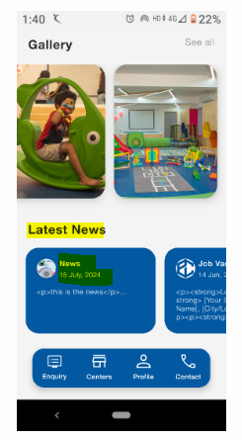

TC_002

Verify that images in the "Gallary" section are displayed properly

1.Launch the application > 2.Navigate to the "Gallary" section > 3.Verify that images load without errors > 4.Check if images are aligned correctrly

Working as expected

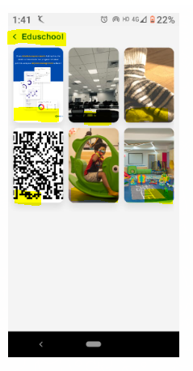

TC_003

Verify that tapping on the bottam navigation buttons redirects to the correct pages

1.Launch the application > 2.Tap on "News" and check if it is navigates to the Enquiry page

Working as expected

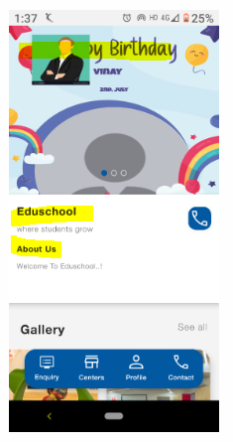

TC_004

Verify that tapping on the bottam navigation buttons redirects to the correct pages

1.Launch the application > 2.Tap on "Job Vacancy" and check if it is navigates to the Enquiry page

working as expected



TC_005

Verify that the page loads within an acceptable time

1.Launch the application > 2.Navigate to this page > 3.Measure the page load time

The page is loaded within 2-3 seconds

TC_006

Verify that all UI elements are properly aligned readable

1.Launch the application > 2.Verify that all UI elementstes(text,buttons,images)are aligned properly > 3.check font size and color contrast for readability > 4.Verify different screen sizes

UI element is not properly aligned

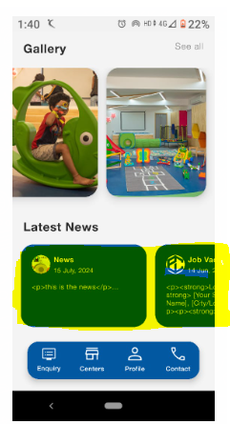

TC_007

Ensure that all text is readable and follows guidelines

1. Launch the application  
2. Verify that all text has sufficient contrast against the background  
3. Check if font size is appropriate for readability  
4. Use screen readers to verify text accessibility

Text is clearly readable, and screen readers should work correctly



TC_008

Ensure that all API calls use HTTPS and secure authentication

1. Launch the application > 2. Monitor network requests using a proxy tool (e.g., Postman, Burp Suite) > 3. Check if all API calls use HTTPS > 4. Verify that user data is encrypted during transmission

TC_009

Ensure that the latest news content is retrieved dynamically

1. Launch the application  
2. Scroll to the "Latest News" section  
3. Check if the news updates automatically when new content is added in the backend  
4. Refresh the app and verify updates

The latest news is not appearing dynamically without requiring a full app update

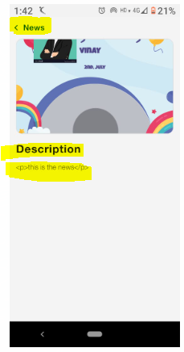

TC_010

Ensure that tapping the "Contact" button opens the correct contact page or dialer

1. Launch the application > 2. Tap on the "Contact" button > 3. Check if it opens the dialer or contact details page

correct contact details page or phone dialer is opened

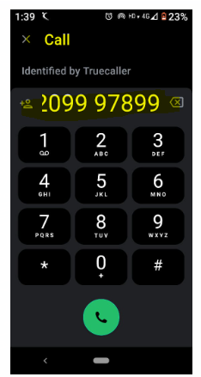

TC_011

1. Open the application on various devices (small, medium, large screen sizes)  
2. Verify that the UI elements (Gallery, Latest News, Buttons) adjust properly  
3. Check for any overlapping or misaligned elements

The UI is not adjust properly breaking the layout

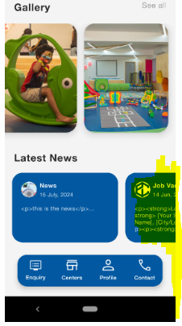

TC_012

Ensure that the app functions correctly across different Android OS versions

1. Install and launch the app on devices with different Android versions (e.g., Android 10, 11, 12, 13)

2. Navigate through the app and check for crashes or UI glitches

The app should work smoothly on all supported Android versions

TC_013

Ensure that the app loads properly under different network conditions

1. Launch the app on a high-speed WiFi network

2. Switch to a 4G/5G mobile network and observe loading times

3. Reduce network speed (simulate slow 3G) and check if the app handles it gracefully

The app should load correctly and display an error message if the connection is too slow

TC_014

Ensure that the web version of the app works across different browsers

1. Open the web app on different browsers (Chrome, Firefox, Safari, Edge)

2. Navigate through different sections and check for layout issues

3. Verify if all buttons, links, and images load correctly

The app should function properly across all supported browsers

The app should function properly across all supported browsers

TC_015

Ensure that the app's UI is properly displayed in dark mode

1. Enable dark mode on the device  
2. Launch the app and check if all text and images are visible  
3. Verify that buttons and backgrounds adjust correctly to dark mode

The app is displayed properly in Dark mode

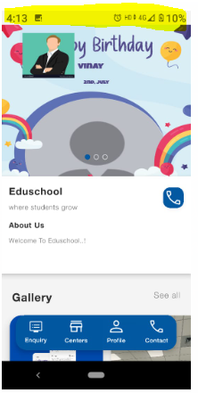

TC_016

Ensure that the app maintains its state when switching between apps

1. Open the app and navigate to the "Latest News" section

2. Switch to another app and return to the test app

3. Verify that the previous screen and data remain intact

Working as expected

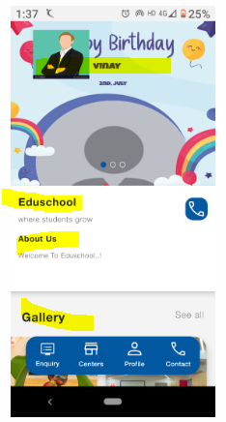

TC_017

Ensure that the app functions correctly on foldable devices

1. Launch the app on a foldable device

2. Fold and unfold the device while keeping the app open

3. Verify that the UI adapts correctly and doesn’t break

The UI should adjust dynamically without breaking

TC_018

Measure the time taken for the app to launch completely

1. Close the app if running in the background

2. Launch the app and measure the time taken to load the home screen

3. Repeat the test multiple times to check consistency

The app is launched within 2-3 seconds

TC_019

Check how the app performs when multiple users access it simultaneously

1. Simulate multiple users logging in and navigating the app

2. Monitor app responsiveness and server response times

3. Check for crashes or slowdowns

The app should remain responsive and not crash

TC_020

Ensure that the app doesn’t consume excessive memory

1. Launch the app and use it for 10-15 minutes

2. Monitor RAM usage using system tools

3. Check for memory leaks

The app should not use excessive memory (>300MB)

TC_021

Ensure that the app doesn’t drain the battery excessively

1. Launch the app and use it continuously for 30 minutes

2. Check battery consumption using device settings

3. Compare battery drain with other similar apps

The app should not drain more than 5% battery in 30 minutes

TC_022

Ensure the app remains functional with poor network conditions

1. Connect the device to a slow 3G network

2. Try loading images and navigating through the app

3. Verify if content loads or if error messages appear appropriately

Working as expected

TC_023

Check database response time for queries

1. Fetch data from the database (e.g., Latest News, Gallery images)

2. Monitor response time

3. Check if delays occur when retrieving large datasets

Database queries should execute within 1-2 seconds

TC_024

Ensure the app performs well even after long usage sessions

1. Open the app and use it continuously for 1 hour

2. Monitor for any slowdowns, crashes, or UI glitches

The app should run smoothly without slowing down

TC_025

Ensure images and videos load within an acceptable time frame

1. Navigate to the Gallery section

2. Observe loading times for images and videos

3. Test with different internet speeds

Working as expected

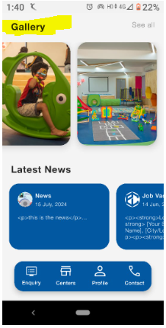

TC_026

Ensure the app doesn’t crash under heavy usage

1. Stress test the app by opening multiple sections quickly

2. Try performing rapid actions (e.g., clicking multiple buttons quickly)

3. Observe if the app crashes

The app should handle stress without crashing

TC_027

Ensure the app displays appropriate messages when offline

1. Disconnect from the internet  
2. Try accessing different sections of the app  
3. Verify if offline mode is available or if proper error messages are shown

App displayed message “No Internet Connection”

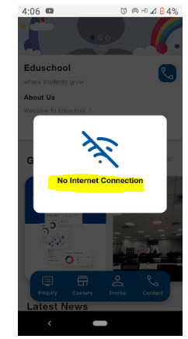

TC_028

Ensure user authentication is secure and prevents unauthorized access

1. Enter valid credentials and log in

2. Enter incorrect credentials multiple times

3. Observe if account lockout is triggered

Users should be able to log in securely, and repeated failures should lock the account temporarily

TC_029

Ensure passwords are stored securely using encryption

1. Register a new user

2. Check database storage of the password

3. Ensure the password is encrypted (hashed)

Passwords should not be stored in plain text

TC_030

Ensure session timeout works correctly

1. Log in and remain inactive for a set period (e.g., 15 minutes)

2. Observe if session expires automatically

3. Attempt to perform actions after session expiry

The app is not logged out

TC_031

Ensure all sensitive data is transmitted over HTTPS

1. Monitor network requests during login and other sensitive actions

2. Check if they use **HTTPS** instead of HTTP

The app should enforce **HTTPS** for secure communication

TC_032

Ensure users can only access authorized sections

1. Log in with different user roles (admin, regular user)

2. Attempt to access restricted pages

3. Observe if access is denied

Users should only have access to their assigned sections

TC_033

Ensure API endpoints are secured from unauthorized access

1. Attempt to access API endpoints without authentication

2. Check if unauthorized requests are rejected

APIs should reject unauthorized requests

TC_034

Ensure users are logged out securely

1. Log in to the app

2. Click the **Logout** button

3. Try accessing protected pages after logging out

Users should be logged out completely and prevented from accessing protected pages

TC_035

Ensure sensitive information is not exposed in error messages

1. Trigger errors (e.g., invalid inputs, database errors)

2. Observe error messages displayed to users

The app should display generic error messages without exposing sensitive data

TC_036

Ensure users can enable two-factor authentication (2FA)

1. Log in and enable 2FA

2. Attempt to log in from a new device

3. Verify if an OTP is required

Users should need a second authentication factor to log in

TC_037

Ensure the search bar returns relevant results

1. Enter a search term in the search bar

2. Check if results are displayed correctly

3. Observe response time

Search bar button is not displaying in app

